Business Case Quick Doc
Introduction
Business Case Conceptual Structure | Definitions
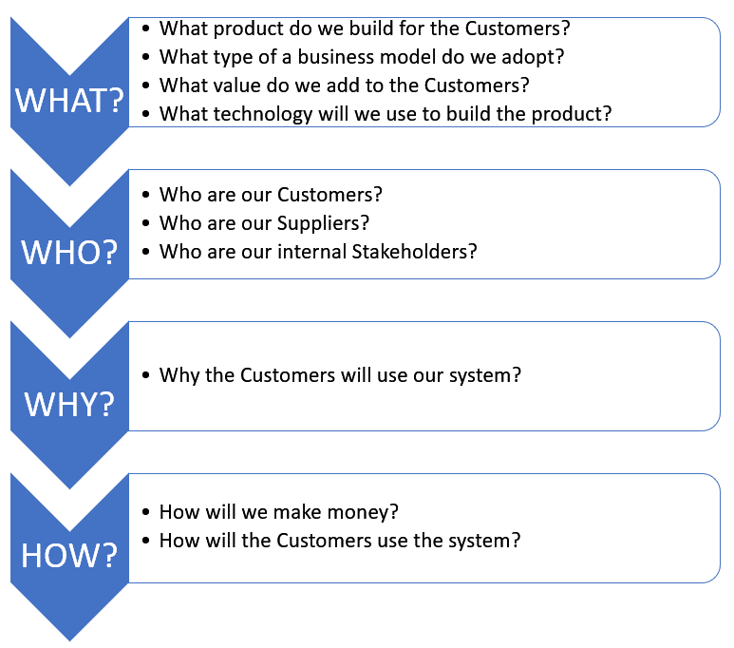 | Customer:  A customer is an individual or business that purchases another company's goods or services.  Customers are important because they drive revenues; without them, businesses cannot continue to exist.  Supplier:  A supplier is a person, business, or entity that provides products, data or services to another entity.  Stakeholder:  A person with an interest or concern in something, especially a business.  Stakeholders encompass all individuals or groups who have a vested interest in the performance of the business.  Note, application team is a Delivery Team, not Stakeholder.  Business Model:  The term business model refers to a company's plan for making a profit. Examples: Freemium, Subscription, Advertising, etc.  Distribution Channel:  A distribution channel is a path that a product or service could take on its way to market. What's a direct distribution channel? A direct distribution channel is one where a company sells directly to the consumer, usually through their website or retail store.

Team No: 4
Application Name: QuickDoc
Category | BC Section | Questions | Answers
WHAT? | Product Overview | Give a brief description of the proposed software product. | QuickDoc is a web-based healthcare appointment booking platform that connects patients with doctors and clinics. The application allows patients to search for doctors by specialty, location, and availability, book appointments online, receive reminders, and provide reviews. Clinic administrators can manage doctor schedules, track appointments, and generate reports.
 | Value Propositions | What Customer business needs are we satisfying? | The patient portal system satisfies several important customer needs for both patients and healthcare providers:  - Convenience for Patients:  Patients can schedule appointments via various devices (laptop, tablet, computer, or smartphone) in a convenient and user-friendly manner. This addresses the need for a hassle-free appointment scheduling process.  - 24/7 Accessibility:  Patients have the flexibility to make appointments at any time and from anywhere, 24/7. This meets the demand for healthcare services that are accessible beyond regular office hours.  - Efficiency for Doctors:  Doctors can easily review their daily appointment schedules, which streamlines their workflow and helps them plan their day effectively. This addresses the need for efficient appointment management tools.  - Access to Patient Details:  Doctors being able to view patient details and medical records is crucial for providing personalized and informed medical care. This satisfies the need for healthcare professionals to have comprehensive patient information readily available.
 |  | What value do we add to the Customers? | Value for Healthcare Providers (Doctors):  - Professional Reputation  Effective use of the system can enhance a doctor's professional reputation by providing high-quality, patient-centered care and efficient appointment management.  - Enhanced Patient Engagement  The system improves communication between doctors and patients, fostering better patient engagement, which can lead to higher patient satisfaction and improved health outcomes.  Value for Patients:  - Reduced Wait Times  By viewing doctors' availability, patients can select appointment times that align with their schedules, choose suitable time slots, eliminating the need for time-consuming phone calls or in-person visits.
 | Type of Business Model | What type of a business model do we adopt? | Subscription & Advertising Model  Doctors or healthcare providers pay a subscription fee to use the patient portal system as part of their practice. Patients access the system for free.  Our patient portal can display targeted advertisements to users. These ads can be related to healthcare plans, pharmaceuticals or medical devices, Healthcare providers and advertisers pay our patient portal for advertising space.
 | Key Resources | What Key Resources do our value propositions require? | The key resources required to support the value propositions of our patient portal system include:  - Development Team:  The development team is crucial to create, maintain, and update web applications and ensure compatibility with hosting platforms and database that form the patient portal system.  - Technology Infrastructure:  Technology infrastructure is essential to ensure the patient portal system runs smoothly. This includes servers, hosting platforms, cloud services, and the necessary hardware and software components.
 |  | What are our Distribution Channels? | Our distribution channels focus on digital platforms and partnerships to reach a broad audience within the healthcare ecosystem.  - Website  Our website serves as a central distribution channel where healthcare providers and patients can learn about our patient portal system, sign up for the services.  - Social Media Pages  Utilizing social media platforms such as Facebook, Twitter, LinkedIn, and others allows us to reach and engage with a broader audience. We can use these platforms to share updates, educational content, and engage with potential customers.  - Collaborations with Healthcare-Related Websites and Organizations  Partnering with healthcare-related websites and organizations will allow us to leverage their credibility and reach. These collaborations can include joint marketing efforts, co-hosted webinars, or integration with their platforms.
 | Technology | What technology will we use to build the product? | Front-end technology:  HTML, CSS, JAVASCRIPT  Back-end technology:  Python 3.x with Flask/Django Framework, PostgreSQL
 |  | Is it a mobile or Web/desktop application? | It is a desktop application.
 | Known Prototypes | What are the know prototypes of your product?  Reference some known portals on the Internet that are similar to your product. You will use these prototypes for developing business, user requirements. | List of Prototypes:  https://mychart.pascackmedicalcenter.com/PVC/Authentication/Login?error=IDMISSING  https://21260-1.portal.athenahealth.com  https://east.optum.com/helpful-resources/patient-portal-new-york-caremount-medical/
WHO? | External Customers | Who are our customers? | The customers for your patient portal system can be categorized into two main groups:  - Healthcare Providers (Doctors, Clinics, Hospitals)  - Patients
 | External Suppliers | Who are our Suppliers?  Does the system exchange data with external systems? For example, banks, delivery contractors, restaurants, etc. | Pharmacies serve as suppliers.  Pharmacies can supply medications prescribed by doctors to patients. The patient portal system can facilitate the process of sending prescription information to pharmacies, allowing patients to conveniently pick up their medications.  Our patient portal requires external interfaces to exchange data with various external systems to provide the necessary functionalities. Here are some external systems that our portal may need to interface with:  - Clinical Labs  To display test results to patients. The patient portal needs to connect with clinical laboratories like Quest Diagnostics. This interface allows for the secure and timely transmission of lab test data to the patient's portal account.  - Payment Gateways  To facilitate online bill payments, our patient portal will integrate with a payment gateway or payment processing system. This integration ensures that patients can make secure payments for healthcare services, bills, or co-pays directly through the portal.  - Email Exchange System  When a patient registers for or uses the patient portal, they may receive email confirmations for actions like account registration, appointment scheduling, password resets, or changes to personal information. These email confirmations help verify and authenticate user actions, providing an added layer of security and ensuring that patients are informed about important events related to their healthcare.
 | Internal Stakeholders | Who are our internal Stakeholders?  Do we need a product development group?  Do we need a sales group?  Do we need a finance group (accounts payable, receivable)?  Do we need a customer support team?  Do we need an advertising management group? | Our internal stakeholders are the business operation teams responsible for running and growing QuickDoc  Yes, we will need a product development team. Our patient portal system is complex, involving multiple features and integrations, having a dedicated product development group can be beneficial. This group can focus exclusively on designing, developing, testing, and maintaining the system.  No, we do not have an immediate need for a sale team, as our distribution channels are primarily digital through our website and social media. Leveraging these digital platforms can effectively promote and distribute our patient portal services to the target audience and advertisers  Yes, we will need a finance group who is responsible for managing invoices and processing payments. This ensures that financial transactions related to patient billing are handled accurately and securely.  No, we do not have the immediate need for a customer support team as we are in the early stages of development and usage. However, as our patient portal expands and more patients use it for various healthcare-related activities, the demand for customer support is likely to increase.  Yes, we will need an advertising management group. Having a dedicated advertising team will play a crucial role in effectively managing and optimizing the advertisements on our patient portal system. This group will oversee ad placements, negotiate with advertisers, monitor ad performance, ensure optimal advertising revenue generation, contributing to the overall success of our digital platform.
WHY? | Expected Benefits to the Customer | Why do we believe our new product will be better than those already existing on the market? | We believe that our new Patient Portal system will be better than the existing solutions on the market for following reasons:  - User-Centric Design  Our system has user-friendly design for three primary user groups:  administrators, doctors, and patients.  - The administrator serves as the system manager responsible for maintaining doctor and system data. The admin populates the system with a list of doctors, including their specialties, contact details, and system credentials. They also manage the overall system settings and access controls.  - Doctors use the system to manage their appointments, appointment requests and patient information.  - Patients use the system to find and request appointments with doctors.  - Customization and Scalability  We offers customization options that allow users to tailor the product to their specific needs, such as Email functionality, Chart.js integration, etc.  - Responsive Support  We offer exceptional customer support and technical assistance for doctors and patients which can contribute to a positive user experience.
 |  | Why the Customers would want to use our system? | The customers would want to use our Patient Portal system for various compelling reasons:  For Healthcare Providers (Doctors):  - Efficient Appointment Management: Our system streamlines appointment scheduling and management, allowing doctors to optimize their schedules and reduce administrative burdens.  - User-Friendly Interface: The system's user-friendly design makes it easy for doctors to navigate and use, reducing the learning curve and increasing efficiency.  - Customization: Doctors can customize their availability, preferences, and patient communication to suit their individual practice needs.  For Patients:  - Convenient Appointment Scheduling: Patients can easily find doctors based on specialties, view availability, and schedule appointments at their convenience, reducing the hassle of phone calls and in-person visits.  - Access to Healthcare Information: Patients can access their medical records, test results, and treatment plans online, empowering them to take a more active role in their healthcare.  - Reduced Wait Times: With the ability to view doctors' availability, patients can choose appointment times that suit their schedules, reducing waiting times at the healthcare facility.  - User-Friendly Design: A user-friendly interface makes it easy for patients to navigate and use the system, even for individuals with varying levels of digital literacy.  - Transparency: Patients can view doctor profiles, including specialties and reviews, helping them make informed decisions about their healthcare providers.
HOW? | System Use | How will the External Customers use the system?  What is the main system use scenario for the External Customers? | Here's a breakdown of how external customers (patients) will use the system:  - Registration and Account Creation:  Patients start by registering on the Patient Portal system. They provide personal information and create an account with a unique username and password.  - Browsing and Searching:  - After registration, patients can log in to the system.  - Patients browse the system to search for healthcare providers (doctors) based on specialties, location, or other criteria. They can view doctor profiles and learn more about their qualifications and reviews from other patients.  - Appointment Scheduling:  - Patients select a healthcare provider based on their needs and availability.  - They can view the doctor's weekly schedule and select a suitable date and time for their appointment.  - Patients submit their appointment request, specifying their preferred date and time.  - Appointment Confirmation:  Once the appointment request is submitted, the system displays a confirmation notification to the patient, indicating that their request is under confirmed.  - Accessing Medical Data and View Lab Test Results  Patients, upon logging into the patient portal, have the ability to access their medical data, including lab test results and medical history.  - Bill Payment:  - Patients have the option to view and pay their medical bills through the patient portal.  - They can access their billing statements, review charges, and choose a payment method.  - Patients make online payments for their healthcare services, bills, or co-pays directly through the portal.  The main system use scenario for external customers (patients) in the Patient Portal system revolves around accessing healthcare services, scheduling appointments, managing healthcare information, viewing and paying their medical bills through the patient portal, and engaging in secure communication with healthcare providers.
 |  | What is the main system use scenario for the Internal Users? | Here's detail how internal customers Healthcare Providers (Doctors) will use the system:  - View Weekly Schedule:  Upon logging in, the doctor is presented with their weekly schedule. This schedule displays existing appointments and available time slots for the current week.  - Schedule New Appointments:  If there are available time slots, the doctor can manually schedule new appointments for patients directly in the system. This is particularly useful for patients who calls in to schedule appointments.  - Access Patient Information:  The doctor can access patient profiles and medical records within the system. This includes information such as medical history, test results, treatment plans, and previous appointment notes.  - Set Availability and Preferences:  The doctor has the option to set their availability, update contact information, and configure communication preferences within the system.
 | Revenue Generation, Revenue Streams | How will we make money?  Such as Subscription fees, renting, leasing, licensing, brokerage fees, advertising sales, etc. | Here are some ways we can make money:  1.Premium Subscriptions for Clinics - Monthly/annual plans for clinics for advanced features, analytics, and priority listing  2.Featured Listings - Doctors and clinics pay for premium placement in search results  3.Commission on Bookings - 5-10% fee per confirmed appointment  4.Payments for Doctors' Services - Transaction fee (2-5%) on patient payments for consultations and medical services processed through the platform  5.Advertising Revenue - Healthcare-related advertisements from pharmacies, labs, and medical suppliers  6.Premium Patient Features - Optional paid features for patients like priority booking, no ads, etc.

